WEEK4

Q1) Alice and Bob are playing a game called "Stone Game". Stone game is a two-player game. Let N bethetotalnumberofstones.Ineachturn,aplayercanremoveeitheronestoneorfourstones.The player who picks the last stone, wins. They follow the "Ladies First" norm. Hence Alice is always the one to make the first move. Your task is to find out whether Alice can win, if bothplay the game

optimally. InputFormat

FirstlinestartswithT,whichisthenumberoftestcases.EachtestcasewillcontainNnumberof stones.

OutputFormat

Print"Yes"inthecaseAlicewins,elseprint"No"Constraints

1<=T<=10001<=N<=10000

SampleInputandOutput Input

3

1

6

7

Output Yes

Yes No

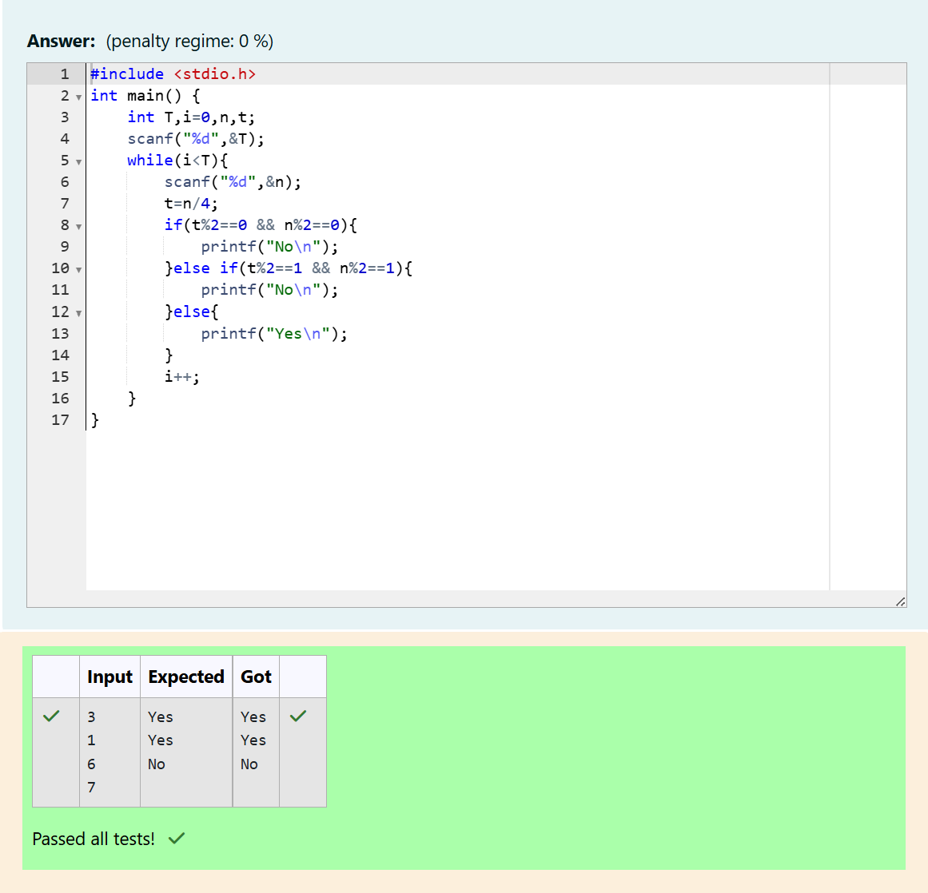

Q2)Youaredesigningaposterwhichprintsoutnumberswithauniquestyleappliedtoeachof

them. The styling is based on the number of closed paths or holes present in a given number. The numberofholesthateachofthedigitsfrom0to9haveareequaltothenumberofclosedpathsin the digit. Their values are:

1,2,3, 5,and7=0 holes.

0,4,6,and9=1 hole.

8 =2 holes.

Givenanumber,youmustdeterminethesumofthenumberofholesforallofitsdigits. For example, the number 819 has 3 holes.

Completetheprogram,itmustmustreturnanintegerdenotingthetotalnumberofholesinnum. Constraints 1 ≤ num ≤ 109

InputFormatForCustomTesting

Thereisonelineoftextcontainingasingleintegernum,thevaluetoprocess. Sample Input

630

SampleOutput 2

Explanation

Addtheholescountforeachdigit,6,3and0.Return1+0+1=2.

SampleCase1 Sample Input 1288

SampleOutput 4

Explanation

Addtheholescountforeachdigit,1,2,8,8.Return0+0+2+2=4.

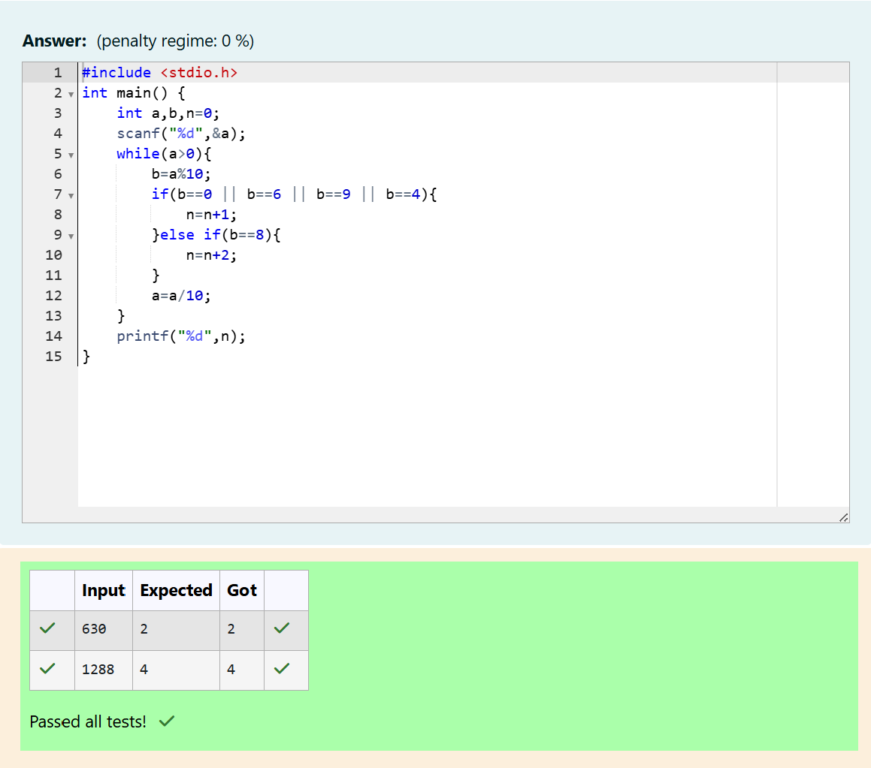

Q3) The problem solvers have found a new Island for coding and named it as Philaland. These smart people were given a task to make a purchase of items at the Island easier by distributing various coins with different values. Manish has come up with a solution that if we make coins category startingfrom$1tillthemaximumpriceoftheitempresentonIsland,thenwecanpurchaseanyitem easily. He added the following example to prove his point.

Let’ssupposethemaximumpriceofanitemis5$thenwecanmakecoinsof{$1,$2,$3,$4,$5}to purchaseanyitemrangingfrom$1till$5.NowManisha,beingakeenobserversuggestedthatwe couldactually minimize thenumber of coins requiredandgave followingdistribution {$1,$2, $3}.

Accordingtohimanyitemcanbepurchasedonetimerangingfrom$1to$5.Everyonewas impressed with both of them.

YourtaskistohelpManishacomeupwithaminimumnumberofdenominationsforanyarbitrary max price in Philaland.

InputFormat

ContainsanintegerNdenotingthemaximumpriceoftheitempresentonPhilaland. Output Format

Printasinglelinedenotingtheminimumnumberofdenominationsofcoinsrequired. Constraints

1<=T<=1001<=N<=5000

Referthesampleoutputforformatting Sample Input 1: 10

SampleOutput1:4

SampleInput2:5

SampleOutput2:3

Explanation:Fortestcase1,N=10.AccordingtoManish{$1,$2,$3,…$10}mustbedistributed.But asperManishaonly{$1,$2,$3,$4}coinsareenoughtopurchaseanyitemrangingfrom$1to$10. Hence minimum is 4.

Likewisedenominationscouldalsobe{$1,$2,$3,$5}.Henceanswerisstill4.

For test case 2, N=5. According to Manish {$1, $2, $3, $4, $5} must be distributed. But as per Manishaonly{$1,$2,$3}coinsareenoughtopurchaseanyitemrangingfrom$1to$5.Hence minimum is 3. Likewise, denominations could also be {$1, $2, $4}. Hence answer is still 3.

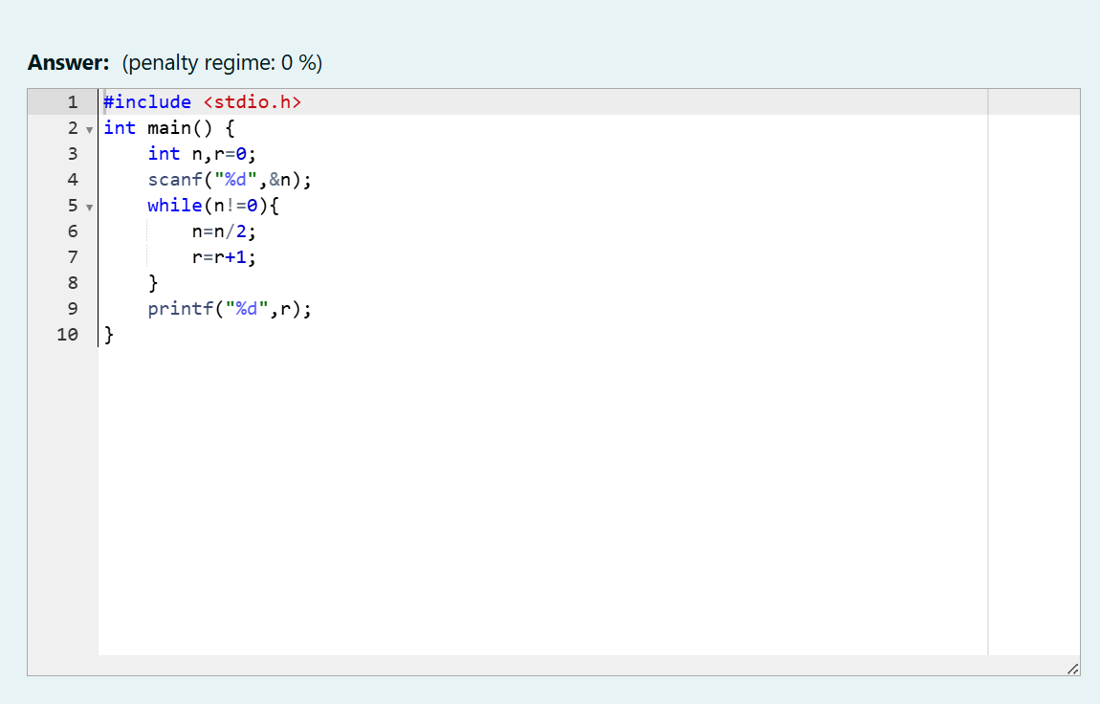

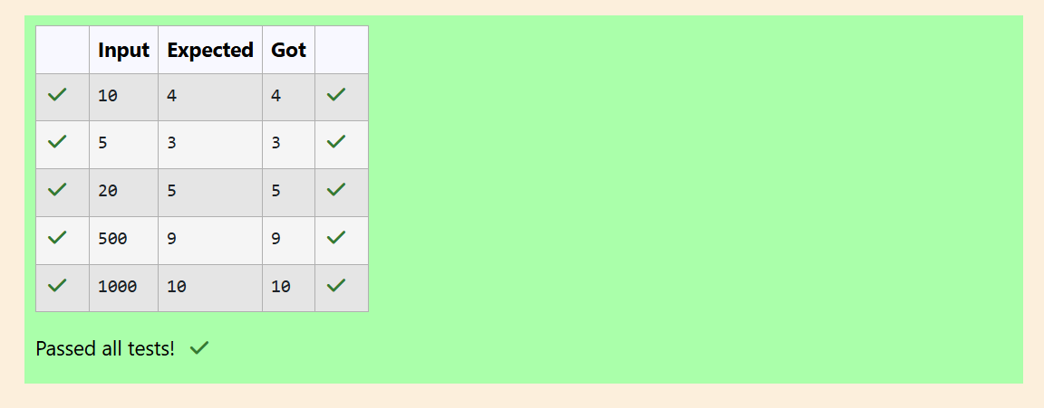

Q4)AsetofNnumbers(separatedbyonespace)ispassedasinputtotheprogram.Theprogram must identify the count of numbers where the number is odd number.

InputFormat:ThefirstlinewillcontaintheNnumbersseparatedbyonespace. Boundary Conditions: 3 <= N <= 50

Thevalueofthenumberscanbefrom-99999999to99999999

OutputFormat:Thecountofnumberswherethenumbersareoddnumbers. Example

Input/Output 1:

Input:

5101520253035404550

Output:

5

Explanation:

Thenumbersmeetingthecriteriaare5,15,25,35, 45

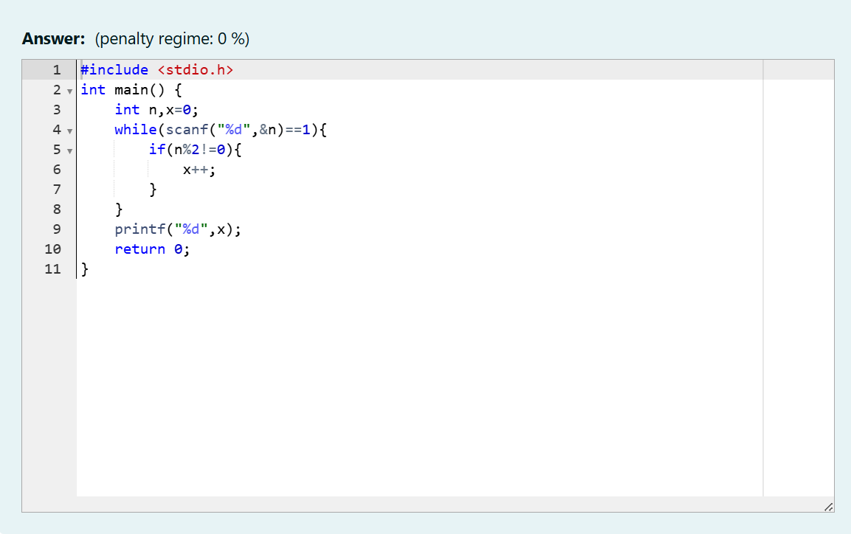

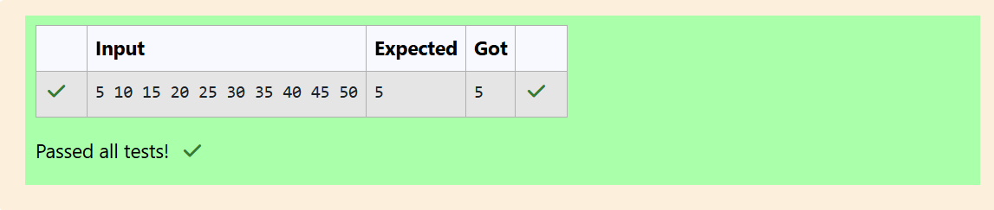

Q5)GivenanumberN,returntrueifandonlyifitisaconfusingnumber,whichsatisfiesthefollowing condition: We canrotatedigits by180 degrees to formnew digits. When 0,1,6,8, 9 arerotated180

degrees,theybecome0,1,9,8,6respectively.When2,3,4,5and7arerotated180degrees,they become invalid.

Aconfusingnumberisanumberthatwhenrotated180degreesbecomesadifferentnumberwith each digit valid.

Example1:

6 ->9

Input: 6 Output:true

Explanation:Weget9afterrotating6,9isavalidnumberand9!=6. Example 2: 89 -> 68

Input: 89 Output:true

Explanation:Weget68afterrotating89,86isavalidnumberand86!=89.

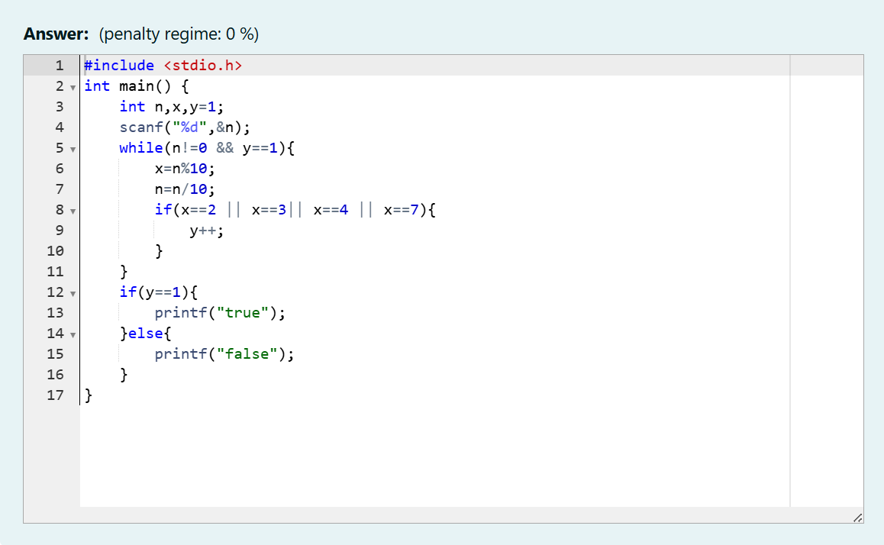

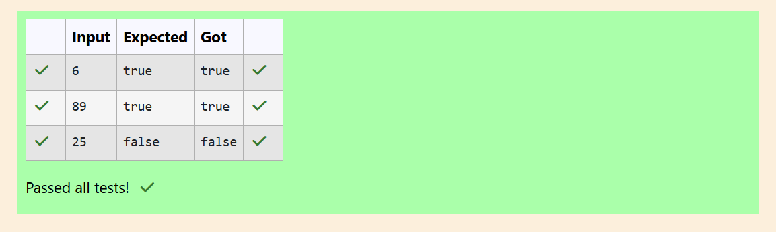

Q6) A nutritionist is labeling all the best power foods in the market. Every food item arranged in a single line, will have a value beginning from 1 and increasing by 1 for each, until all items have a valueassociatedwiththem.Anitem'svalueisthesameas thenumberofmacronutrientsithas.For example, fooditemwith value 1 has1 macronutrient,food itemwith value2 has2 macronutrients, and incrementing in this fashion.

Thenutritionisthastorecommendthebestcombinationtopatients,i.e.maximumtotalof

macronutrients. However, the nutritionistmustavoidprescribinga particular sumof macronutrients (an'unhealthy'number),andthissumisknown.Thenutritionistchoosesfooditemsintheincreasing orderoftheirvalue.Computethehighesttotalofmacronutrientsthatcanbeprescribedtoapatient, without the sum matching the given 'unhealthy' number.

Here'sanillustration:

Given4 food items (hencevalue: 1,2,3 and4), andtheunhealthy sumbeing6 macronutrients,on choosingitems1,2,3->thesumis6,whichmatchesthe'unhealthy'sum.Hence,oneofthethree needs to be skipped. Thus, the best combination is from among:

2 +3+ 4=9

1 +3+ 4=8

1 +2+ 4=7

Since2+3+4=9,allowsformaximumnumberofmacronutrients,9istherightanswer Complete the code in the editor below.

Itmustreturnanintegerthatrepresentsthemaximumtotalofmacronutrients,modulo1000000007 (109 + 7).

Ithasthe following:

n:anintegerthatdenotesthenumberoffooditems k: an integer that denotes the unhealthy number Constraints

1 ≤ n ≤ 2 × 109 1 ≤ k ≤ 4 × 1015 InputFormatForCustomTesting

Thefirstlinecontainsaninteger,n,thatdenotesthenumberoffooditems. Thesecondlinecontainsaninteger,k,thatdenotestheunhealthynumber. Sample Input

0 22

SampleOutput 0 43 3

Explanation-Thefollowingsequenceofn=2fooditems:1.2.Item1has1macronutrients.1+2=3; observe that this is the max total, and having avoided having exactly k = 2 macronutrients.

